**GETTING STARTED WITH ESP32 and ESP-IDF || BLUETOOTH DATA ON OLED DISPLAY**

In this tutorial we will discuss about how to display the data which send from Bluetooth on OLED with ESP-IDF using ESP32. In this tutorial we’ll learn about display the BT data on OLED. So, let’s started and try to understand in much better way...

As we know that we will be using the ESP32 WROOM-32 Dev-kit, for this project which is shown in the pic below.

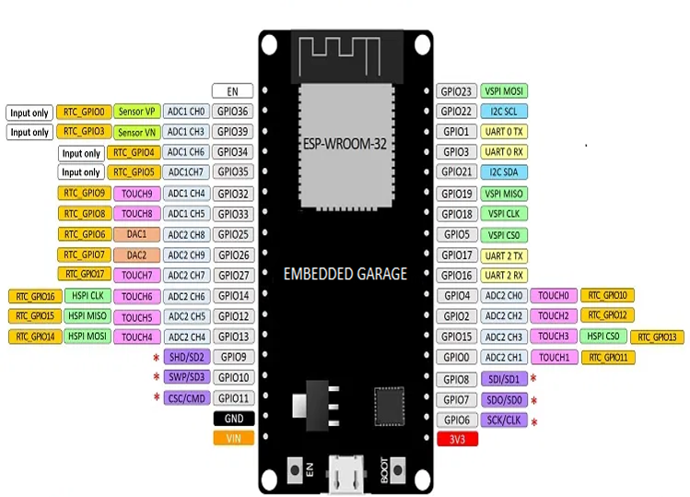

Fig.no 1

**CREATE THE PROJECT FIRST**

Note: we are using VS code for programming and we also installed in the ESP-IDF extensions in VS code. So, its depend on you that which platform you like most VS code or Espressif-IDE. Then after we need to...

Create a new Project where you set the ESP_IDF path. Then give some name of the project, then open the project in VS Code.

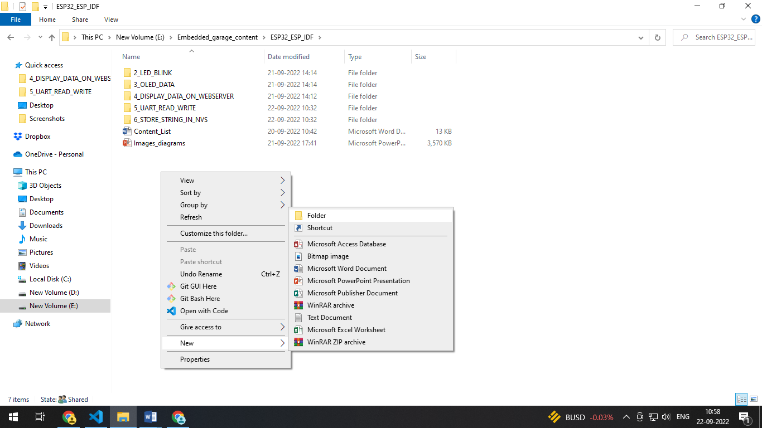

Fig.no 2

After creating the project firstly, we need to write the program of how to display the Bluetooth data on OLED screen. So, we need to define the libraries which are important in the code/programs.

So, lets write the code....

**THE CODE**

Firstly, we adding the Libraries which we used in the code:

#include <stdio.h>

#include "esp_log.h"

#include "driver/i2c.h"

#include "sdkconfig.h"

#include "OLEDDisplay.h"

#include <stdint.h>

#include <string.h>

#include <stdbool.h>

#include "nvs.h"

#include "nvs_flash.h"

#include "freertos/FreeRTOS.h"

#include "freertos/task.h"

#include "esp_bt.h"

#include "esp_bt_main.h"

#include "esp_gap_bt_api.h"

#include "esp_bt_device.h"

#include "esp_spp_api.h"

#include "driver/gpio.h"

#include "time.h"

#include "sys/time.h"

Then define the tag.

static const char *tag = "oled_Bluetooth-example";

Now define the OLED functionality

#define _I2C_NUMBER(num) I2C_NUM_##num

#define I2C_NUMBER(num) _I2C_NUMBER(num)

#define I2C_MASTER_SCL_IO 22               /*!< gpio number for I2C master clock */

#define I2C_MASTER_SDA_IO 21               /*!< gpio number for I2C master data  */

#define I2C_MASTER_NUM I2C_NUMBER(CONFIG_I2C_MASTER_PORT_NUM) /*!< I2C port number for master dev */

SemaphoreHandle_t print_mux = NULL;

OLEDDisplay_t *oled;

Define the Bluetooth Functionality and some variable

#define SPP_SERVER_NAME "SPP_SERVER"

#define EXAMPLE_DEVICE_NAME "ESP32_BT"

#define SPP_SHOW_DATA 0

#define SPP_SHOW_SPEED 1

#define SPP_SHOW_MODE SPP_SHOW_DATA /*Choose show mode: show data or speed*/

static const esp_spp_mode_t esp_spp_mode = ESP_SPP_MODE_CB;

static struct timeval time_new, time_old;

static long data_num = 0;

static const esp_spp_sec_t sec_mask = ESP_SPP_SEC_AUTHENTICATE;

static const esp_spp_role_t role_slave = ESP_SPP_ROLE_SLAVE;

char value;

char bt_data[10] = "";

int ii;

Now create a function esp_spp_cb and put the event in switch case and initialize them.

static void esp_spp_cb(esp_spp_cb_event_t event, esp_spp_cb_param_t *param, void *arg)

{

    // OLEDDisplay_t *oled = OLEDDisplay_init(I2C_MASTER_NUM,0x78,I2C_MASTER_SDA_IO,I2C_MASTER_SCL_IO);

    switch (event)

    {

    case ESP_SPP_INIT_EVT:

        ESP_LOGI(tag, "ESP_SPP_INIT_EVT");

        esp_spp_start_srv(sec_mask, role_slave, 0, SPP_SERVER_NAME);

        break;

    case ESP_SPP_DISCOVERY_COMP_EVT:

        ESP_LOGI(tag, "ESP_SPP_DISCOVERY_COMP_EVT");

        break;

    case ESP_SPP_OPEN_EVT:

        ESP_LOGI(tag, "ESP_SPP_OPEN_EVT");

        break;

    case ESP_SPP_CLOSE_EVT:

        ESP_LOGI(tag, "ESP_SPP_CLOSE_EVT");

        break;

    case ESP_SPP_START_EVT:

        ESP_LOGI(tag, "ESP_SPP_START_EVT");

        esp_bt_dev_set_device_name(EXAMPLE_DEVICE_NAME);

        esp_bt_gap_set_scan_mode(ESP_BT_CONNECTABLE, ESP_BT_GENERAL_DISCOVERABLE);

        break;

    case ESP_SPP_CL_INIT_EVT:

        ESP_LOGI(tag, "ESP_SPP_CL_INIT_EVT");

        break;

    case ESP_SPP_DATA_IND_EVT:

     #if (SPP_SHOW_MODE == SPP_SHOW_DATA)

        ESP_LOGI(tag, "ESP_SPP_DATA_IND_EVT len=%d handle=%d",

                 param->data_ind.len, param->data_ind.handle);

After that we store the data which comes from the Bluetooth in **“value”** variable and display them on **OLED display**.

if (param->data_ind.len < 1023) {

        esp_log_buffer_hex("", param->data_ind.data, param->data_ind.len);

        printf("received length: %d", param->data_ind.len);

        printf("Received info: %s\n", param->data_ind.data);

        }

        for (ii = 0; ii < (param->data_ind.len)-2; ii++)

        {

           value = param->data_ind.data[ii];

           bt_data[ii] = value;

        }

    bt_data[ii] = '\0';

    OLEDDisplay_clear(oled);

    OLEDDisplay_setTextAlignment(oled,TEXT_ALIGN_CENTER);

    OLEDDisplay_setFont(oled,ArialMT_Plain_24);

    OLEDDisplay_drawString(oled,64,20,bt_data);

    OLEDDisplay_display(oled);

    vTaskDelay(500 / portTICK_PERIOD_MS);

    // }

    printf("\n");

    esp_spp_write(param->data_ind.handle, param->data_ind.len, param->data_ind.data);

#else

        gettimeofday(&time_new, NULL);

        data_num += param->data_ind.len;

        if (time_new.tv_sec - time_old.tv_sec >= 3)

        {

            print_speed();

        }

#endif

        break;

    case ESP_SPP_CONG_EVT:

        ESP_LOGI(tag, "ESP_SPP_CONG_EVT");

        break;

    case ESP_SPP_WRITE_EVT:

        ESP_LOGI(tag, "ESP_SPP_WRITE_EVT");

        break;

    case ESP_SPP_SRV_OPEN_EVT:

        ESP_LOGI(tag, "ESP_SPP_SRV_OPEN_EVT");

        gettimeofday(&time_old, NULL);

        break;

    case ESP_SPP_SRV_STOP_EVT:

        ESP_LOGI(tag, "ESP_SPP_SRV_STOP_EVT");

        break;

    case ESP_SPP_UNINIT_EVT:

        ESP_LOGI(tag, "ESP_SPP_UNINIT_EVT");

        break;

    default:

        break;

    }

}

Then after create a esp_bt_gap_cb function and put the event in the switch case and authenticate the Bluetooth functionality.

void esp_bt_gap_cb(esp_bt_gap_cb_event_t event, esp_bt_gap_cb_param_t *param)

{

    switch (event)

    {

    case ESP_BT_GAP_AUTH_CMPL_EVT:

    {

        if (param->auth_cmpl.stat == ESP_BT_STATUS_SUCCESS)

        {

            ESP_LOGI(tag, "authentication success: %s", param->auth_cmpl.device_name);

            esp_log_buffer_hex(tag, param->auth_cmpl.bda, ESP_BD_ADDR_LEN);

        }

        else

        {

            ESP_LOGE(tag, "authentication failed, status:%d", param->auth_cmpl.stat);

        }

        break;

    }

    case ESP_BT_GAP_PIN_REQ_EVT:

    {

        ESP_LOGI(tag, "ESP_BT_GAP_PIN_REQ_EVT min_16_digit:%d", param->pin_req.min_16_digit);

        if (param->pin_req.min_16_digit)

        {

            ESP_LOGI(tag, "Input pin code: 0000 0000 0000 0000");

            esp_bt_pin_code_t pin_code = {0};

            esp_bt_gap_pin_reply(param->pin_req.bda, true, 16, pin_code);

        }

        else

        {

            ESP_LOGI(tag, "Input pin code: 1234");

            esp_bt_pin_code_t pin_code;

            pin_code[0] = '1';

            pin_code[1] = '2';

            pin_code[2] = '3';

            pin_code[3] = '4';

            esp_bt_gap_pin_reply(param->pin_req.bda, true, 4, pin_code);

        }

        break;

    }

#if (CONFIG_BT_SSP_ENABLED == true)

    case ESP_BT_GAP_CFM_REQ_EVT:

        ESP_LOGI(tag, "ESP_BT_GAP_CFM_REQ_EVT Please compare the numeric value: %d", param->cfm_req.num_val);

        esp_bt_gap_ssp_confirm_reply(param->cfm_req.bda, true);

        break;

    case ESP_BT_GAP_KEY_NOTIF_EVT:

        ESP_LOGI(tag, "ESP_BT_GAP_KEY_NOTIF_EVT passkey:%d", param->key_notif.passkey);

        break;

    case ESP_BT_GAP_KEY_REQ_EVT:

        ESP_LOGI(tag, "ESP_BT_GAP_KEY_REQ_EVT Please enter passkey!");

        break;

#endif

    case ESP_BT_GAP_MODE_CHG_EVT:

        ESP_LOGI(tag, "ESP_BT_GAP_MODE_CHG_EVT mode:%d", param->mode_chg.mode);

        break;

    default:

    {

        ESP_LOGI(tag, "event: %d", event);

        break;

    }

    }

    return;

}

Now come to the main function, in the main function initialize the OLED functionality and finally we can display the BT data on OLED.

void app_main(void)

{

    print_mux = xSemaphoreCreateMutex();

    ESP_LOGI(tag,"Running");

    oled = OLEDDisplay_init(I2C_MASTER_NUM,0x78,I2C_MASTER_SDA_IO,I2C_MASTER_SCL_IO);

    // xTaskCreate(i2c_test_task, "i2c_test_task_0", 1024 * 2, (void *)0, 10, NULL);

    esp_err_t ret = nvs_flash_init();

    if (ret == ESP_ERR_NVS_NO_FREE_PAGES || ret == ESP_ERR_NVS_NEW_VERSION_FOUND)

    {

        ESP_ERROR_CHECK(nvs_flash_erase());

        ret = nvs_flash_init();

    }

    ESP_ERROR_CHECK(ret);

    ESP_ERROR_CHECK(esp_bt_controller_mem_release(ESP_BT_MODE_BLE));

    esp_bt_controller_config_t bt_cfg = BT_CONTROLLER_INIT_CONFIG_DEFAULT();

    if ((ret = esp_bt_controller_init(&bt_cfg)) != ESP_OK)

    {

        ESP_LOGE(tag, "%s initialize controller failed: %s\n", __func__, esp_err_to_name(ret));

        return;

    }

    if ((ret = esp_bt_controller_enable(ESP_BT_MODE_CLASSIC_BT)) != ESP_OK)

    {

        ESP_LOGE(tag, "%s enable controller failed: %s\n", __func__, esp_err_to_name(ret));

        return;

    }

    if ((ret = esp_bluedroid_init()) != ESP_OK)

    {

        ESP_LOGE(tag, "%s initialize bluedroid failed: %s\n", __func__, esp_err_to_name(ret));

        return;

    }

    if ((ret = esp_bluedroid_enable()) != ESP_OK)

    {

        ESP_LOGE(tag, "%s enable bluedroid failed: %s\n", __func__, esp_err_to_name(ret));

        return;

    }

    if ((ret = esp_bt_gap_register_callback(esp_bt_gap_cb)) != ESP_OK)

    {

        ESP_LOGE(tag, "%s gap register failed: %s\n", __func__, esp_err_to_name(ret));

        return;

    }

    if ((ret = esp_spp_register_callback(esp_spp_cb)) != ESP_OK)

    {

        ESP_LOGE(tag, "%s spp register failed: %s\n", __func__, esp_err_to_name(ret));

        return;

    }

    if ((ret = esp_spp_init(esp_spp_mode)) != ESP_OK)

    {

        ESP_LOGE(tag, "%s spp init failed: %s\n", __func__, esp_err_to_name(ret));

        return;

    }

#if (CONFIG_BT_SSP_ENABLED == true)

    /* Set default parameters for Secure Simple Pairing */

    esp_bt_sp_param_t param_type = ESP_BT_SP_IOCAP_MODE;

    esp_bt_io_cap_t iocap = ESP_BT_IO_CAP_IO;

    esp_bt_gap_set_security_param(param_type, &iocap, sizeof(uint8_t));

#endif

    /*

     * Set default parameters for Legacy Pairing

     * Use variable pin, input pin code when pairing

     */

    esp_bt_pin_type_t pin_type = ESP_BT_PIN_TYPE_VARIABLE;

    esp_bt_pin_code_t pin_code;

    esp_bt_gap_set_pin(pin_type, 0, pin_code);

}

**RESULT**

Finally, after written the code need to follow some important steps.

* Install the Serial Bluetooth Application.
* Build the code first.
* After successful build up need to select correct port.
* Then, choose the flash method as (UART).
* And finally flash the code to the ESP32.
* See the output (result).

Install the Serial Bluetooth Application.

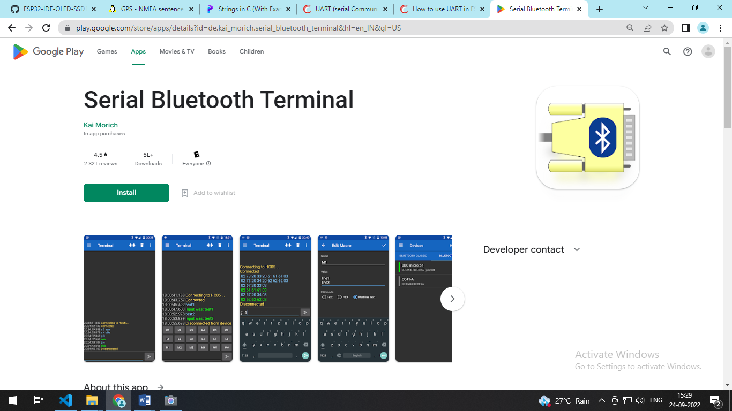

Fig.no 3

Here, my device name is **“ESP32_BT” as you can see below:**

#define EXAMPLE_DEVICE_NAME "ESP32_BT"

Now you can see in the pic below the Bluetooth is initialized and start means the device (esp32) is ready to pair with Bluetooth. So in your mobile turn on the Bluetooth (open the BT) and search the device whatever the name which you put in the code as your device name and pair with that.

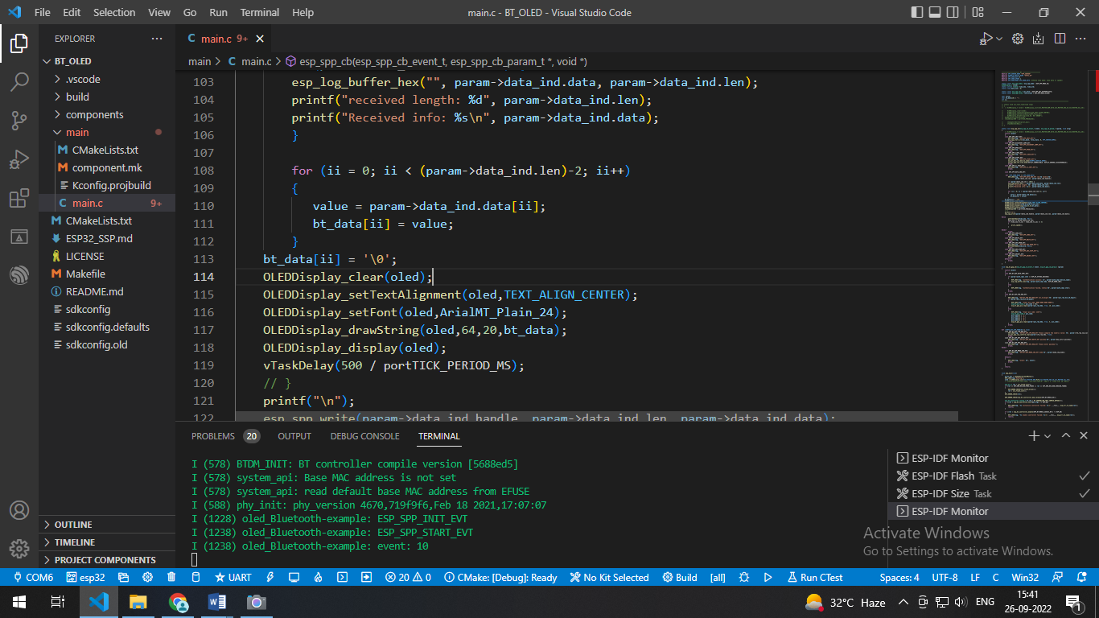

Fig.no 4

Here you can see that when the esp32 is connected then we received a msg.

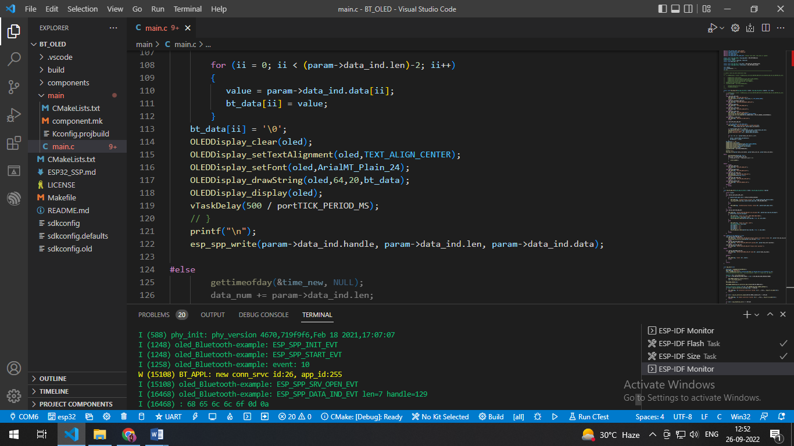

Fig.no 5

Now here you can see the result in the pic below (pic1, pic2), if we sending any data from Bluetooth then the same data is received and display into the OLED screen.

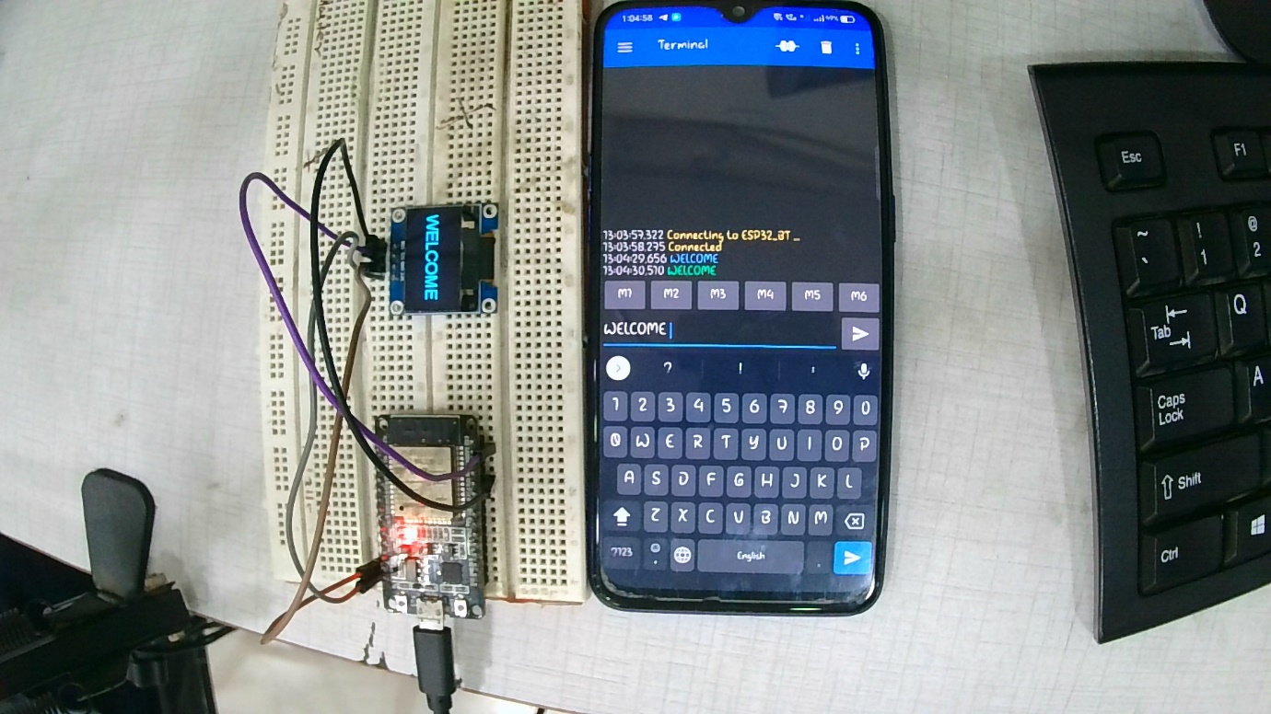

Fig.no 6

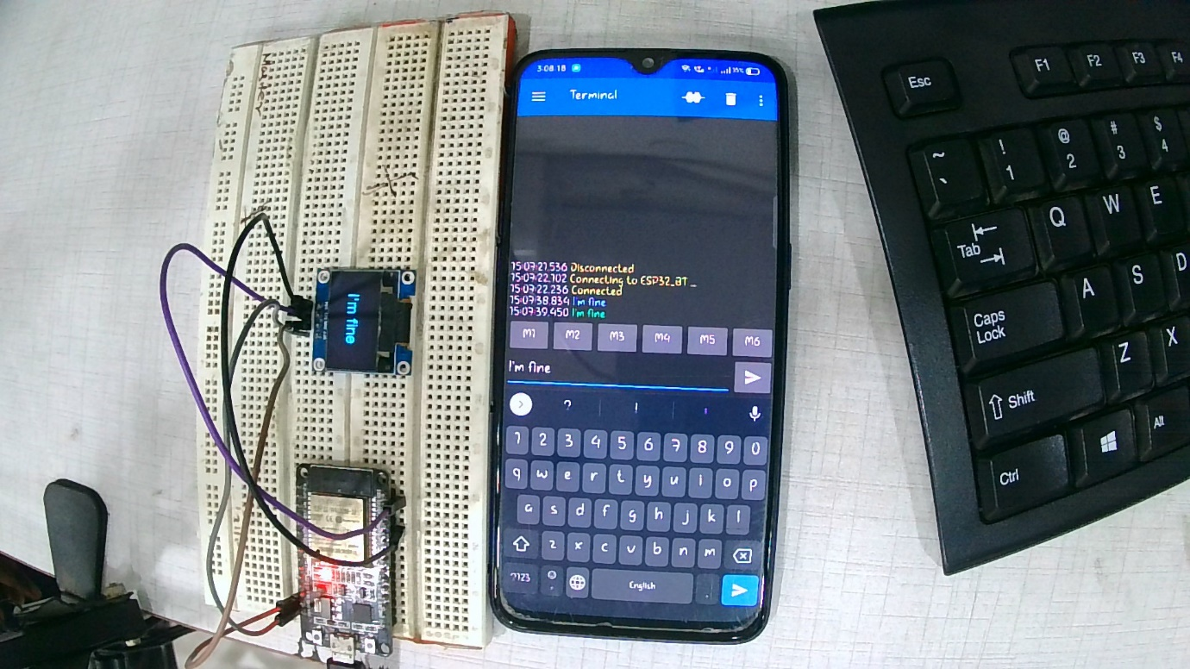

Fig.no 7

**Hope you like this tutorial! Thank you!**